NAME: _____________ | Stats
Interpreting standard deviation | DATE: Monday, February 12, 2018

Click on the link about the Olympics and answer the following questions.
- What does the graph on speedskating tell us?
____________________________________________________________________________________________________________
- What did times seems to improve fastest? _______________
- When was the standard deviation greatest? ______________
- Look at the next graph (on 800m run, high jump and shot put)
  - Which sport had the largest increase in performance? ______________
- What is the general conclusion of this article?
____________________________________________________________________________________________________________

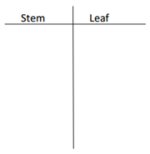Review:

Click on the speedskating link.
Answer these questions.

Find the mean time: ______
Find the median time: ______
Find the minimum time: ______
Find the maximum time: ______
Find the standard deviation: ______

Find quarter 1: ______
Find quarter 3: ______

Create a boxplot that represents that data on speedskaters.

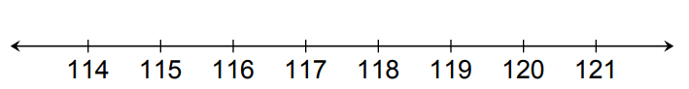
In general terms, standard deviation roughly means “average amount values differ from the mean”

In context: If the average time to text a message was 114 seconds with a standard deviation of 21.
“The average students took 114 seconds to type the messge.
On average, the time students took to type the message differed by 21 seconds from that average of 114 seconds.”

Example 1. The average speed of a car on the highway is 66 mph and the standard deviation is 7 mph.
Interpret what the standard deviation means in context:
__________________________________________________________________________________________________________________________________________________________________

Example 2. The average grade at Deering is 88 and the standard deviation is 5.8. Intrepret what the standard deviation means in context:
__________________________________________________________________________________________________________________________________________________________________

Example 3. The average height of man in America is 5’ 10” and the standard deviation is 3 inches. In China, the average fis 5’ 7” with a standard deviation of 1.5 inches. What does this mean in context?
______________________________________________________________________________________________________________________________________________________________________________________________________________________________________________________________________________

